**BUCKET CREATION**

1. Access the cloud console and go to cloud storage service from the project.

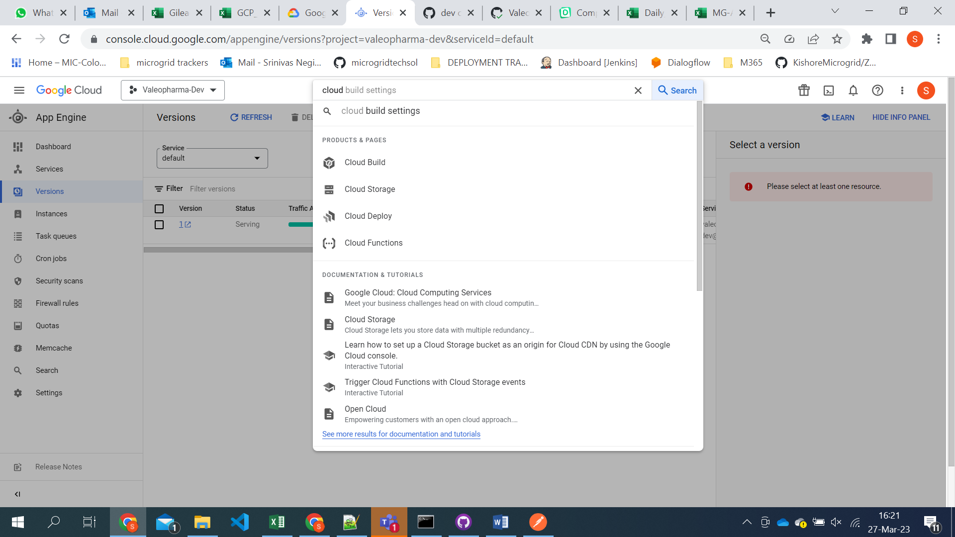

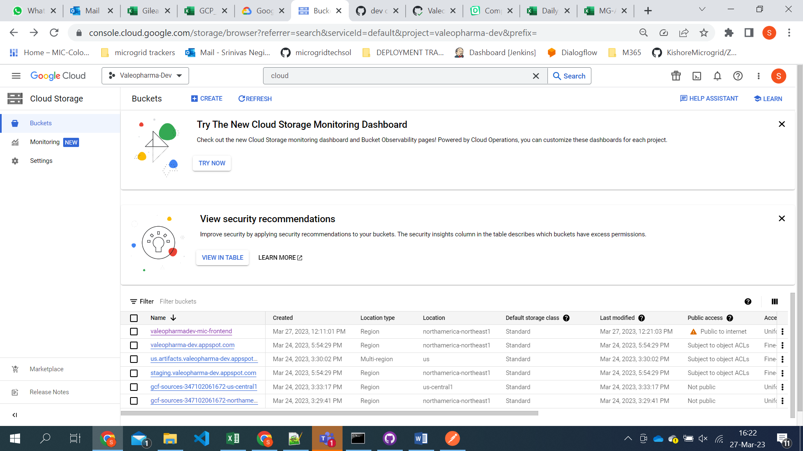

1. Click on the create.

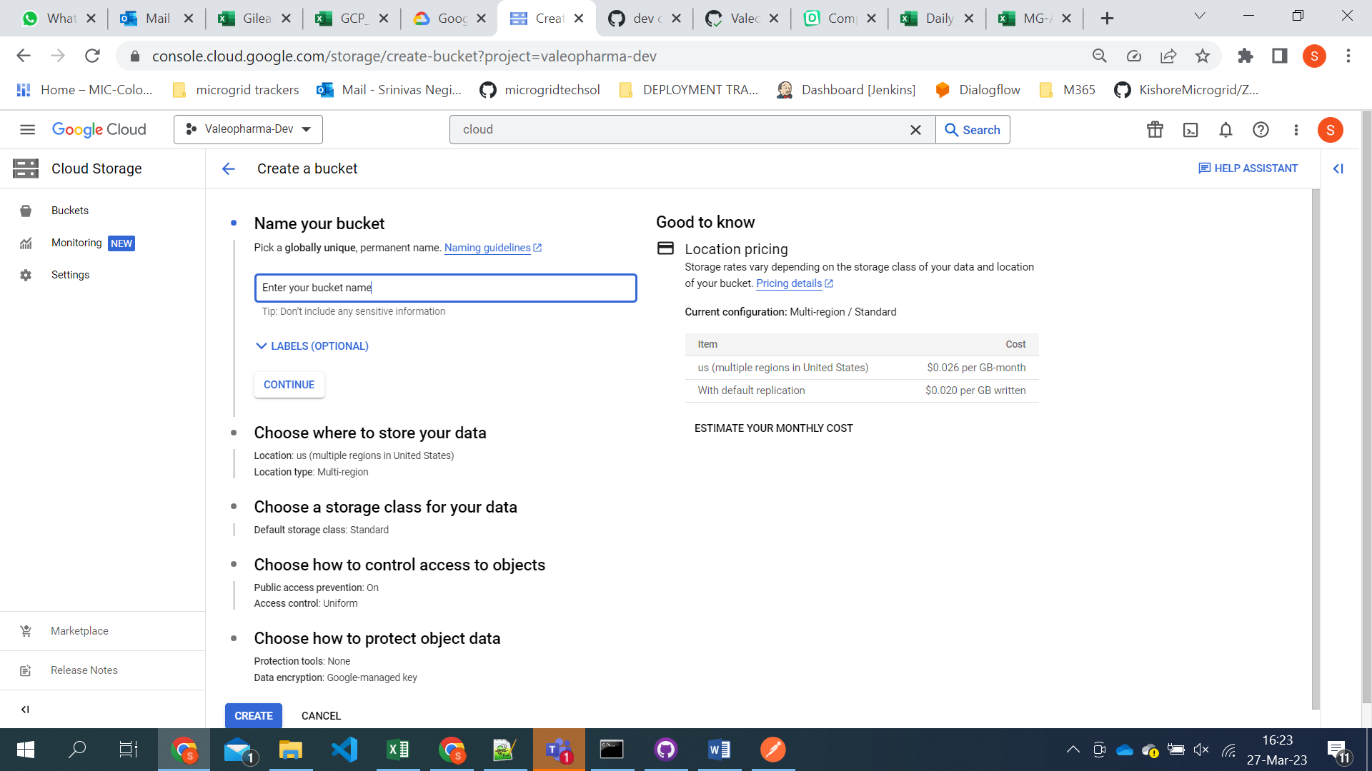

1. Select the region you want to store

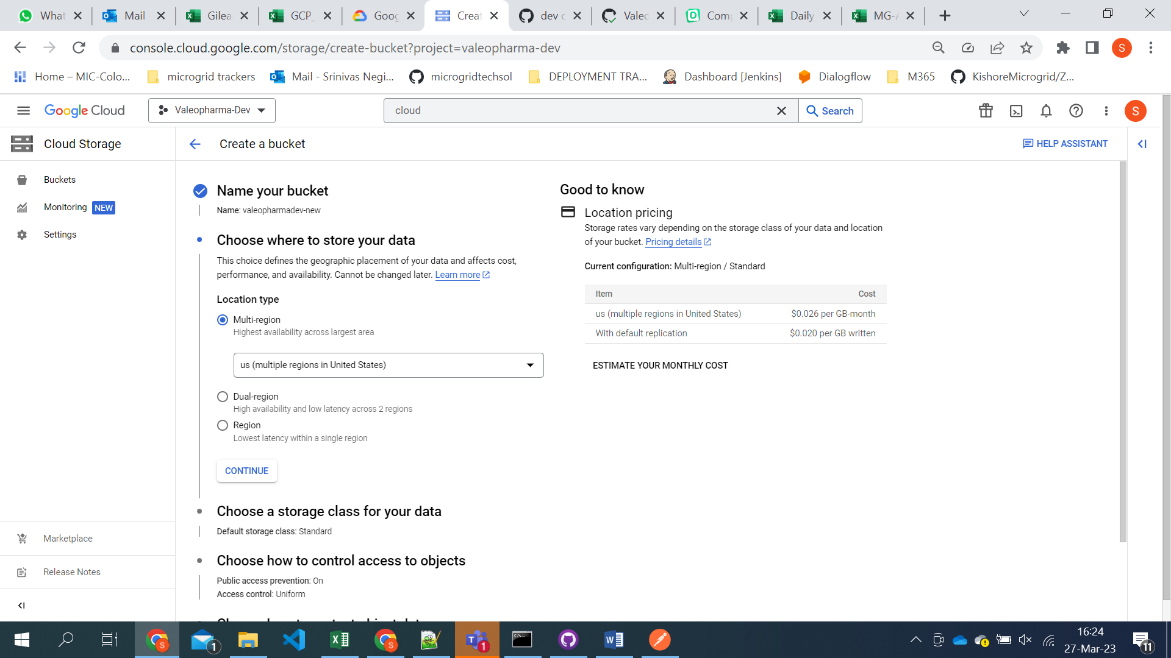

1. Choose the storage class

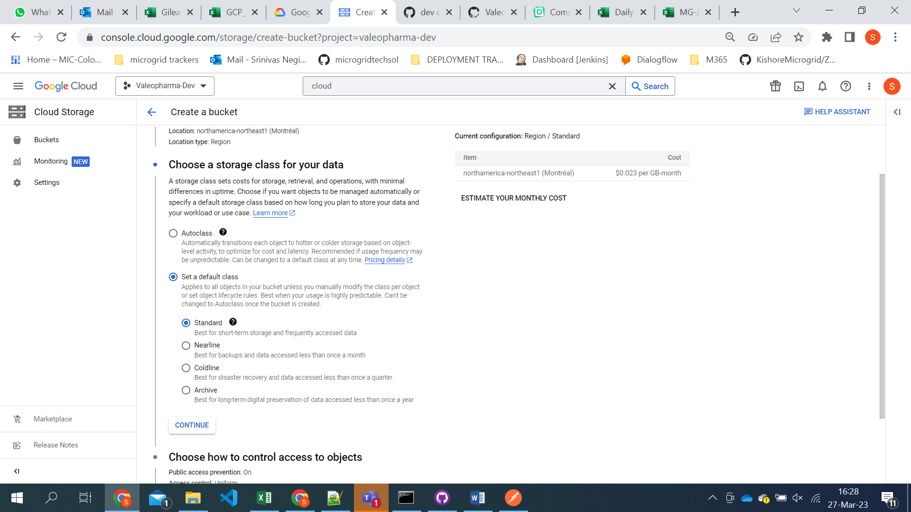

1. Click on the create button and new bucket will be created.
2. Now we need to give all users permissions for the bucket.

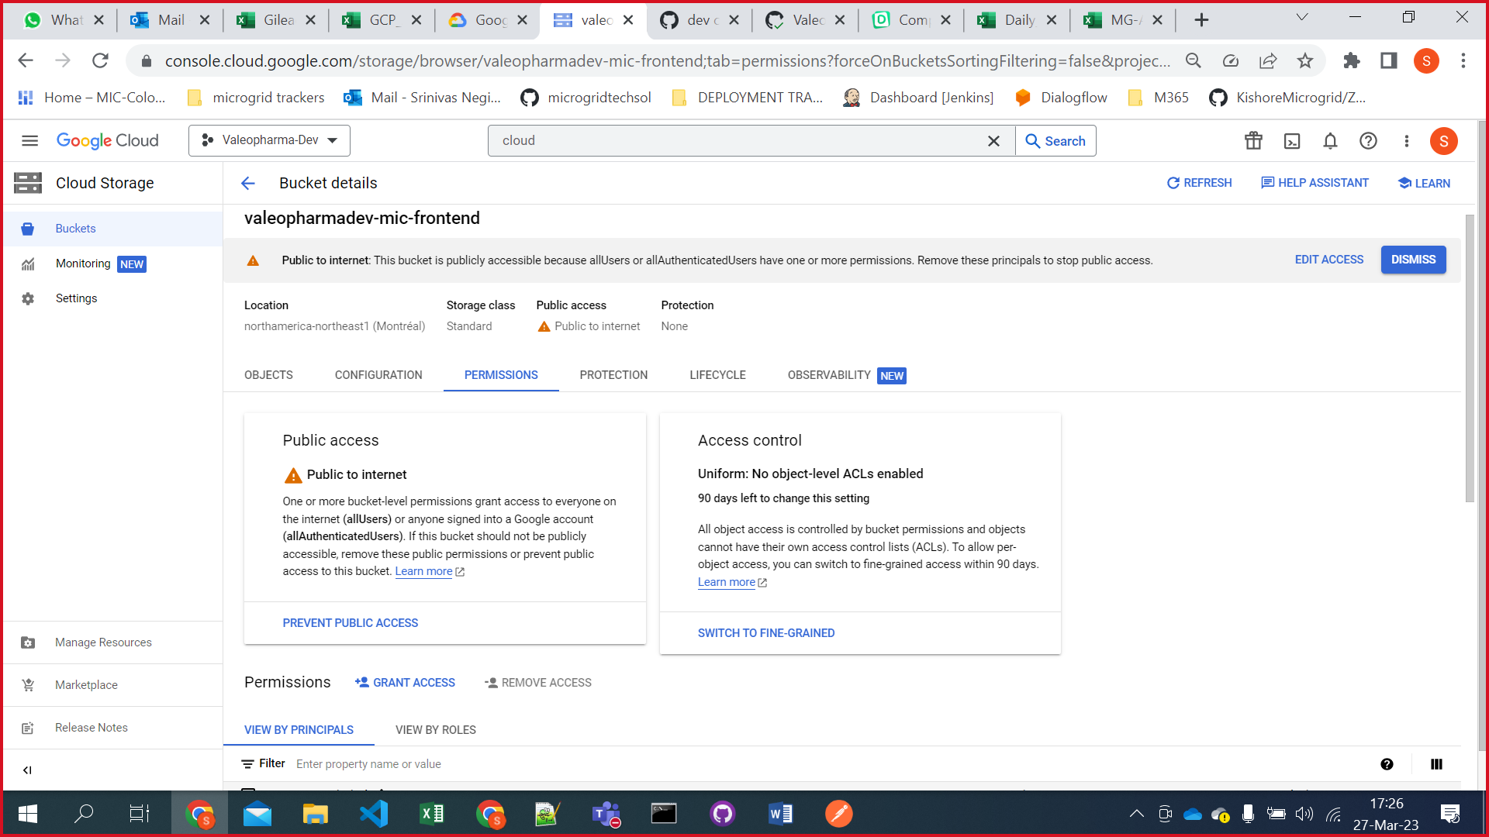

1. After bucket created click on the 3 dot at right side ang go to website settings.

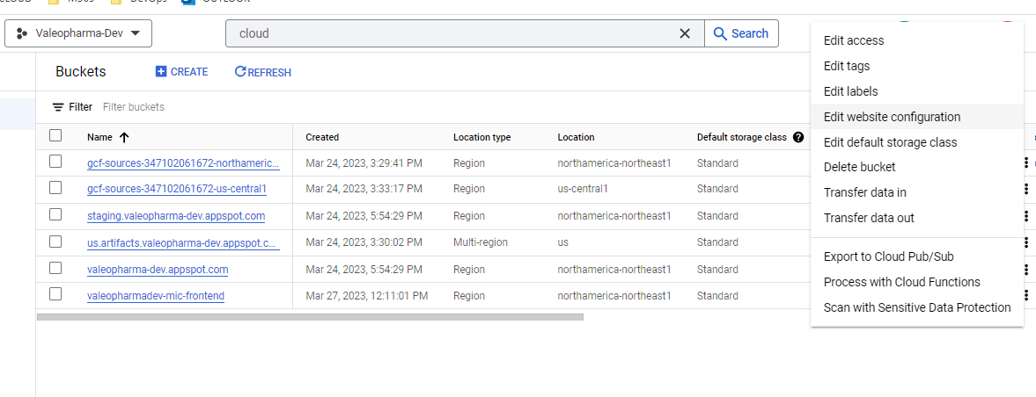

1. We need to provide index page suffix as index.html (This is for accessing chatbot other wise it will load all bucket content)

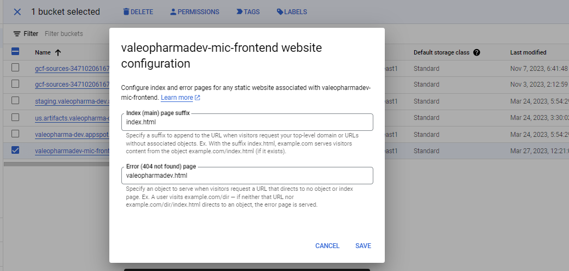

1. Later we need to create a service account in IAM.
2. Go to the IAM section

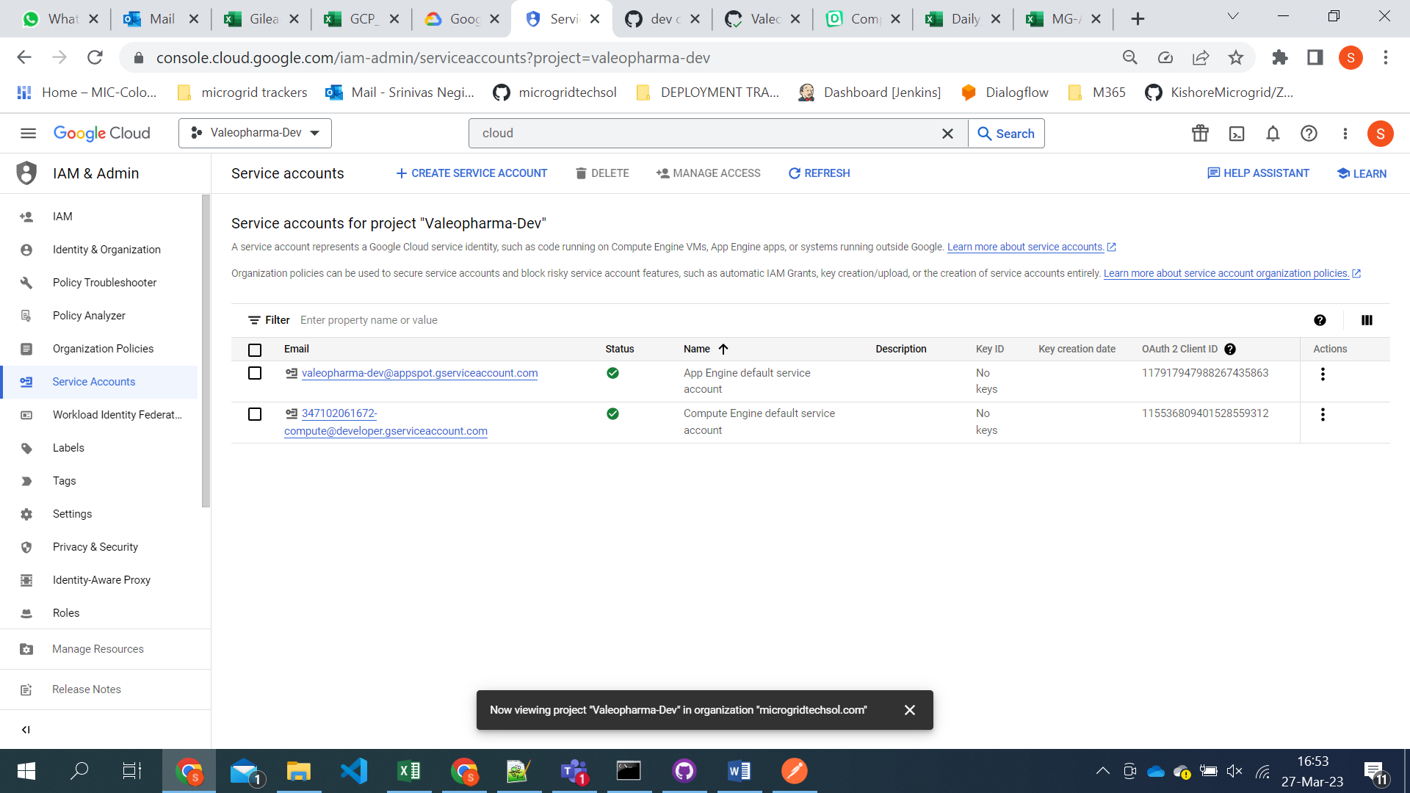

1. Click on create service account.

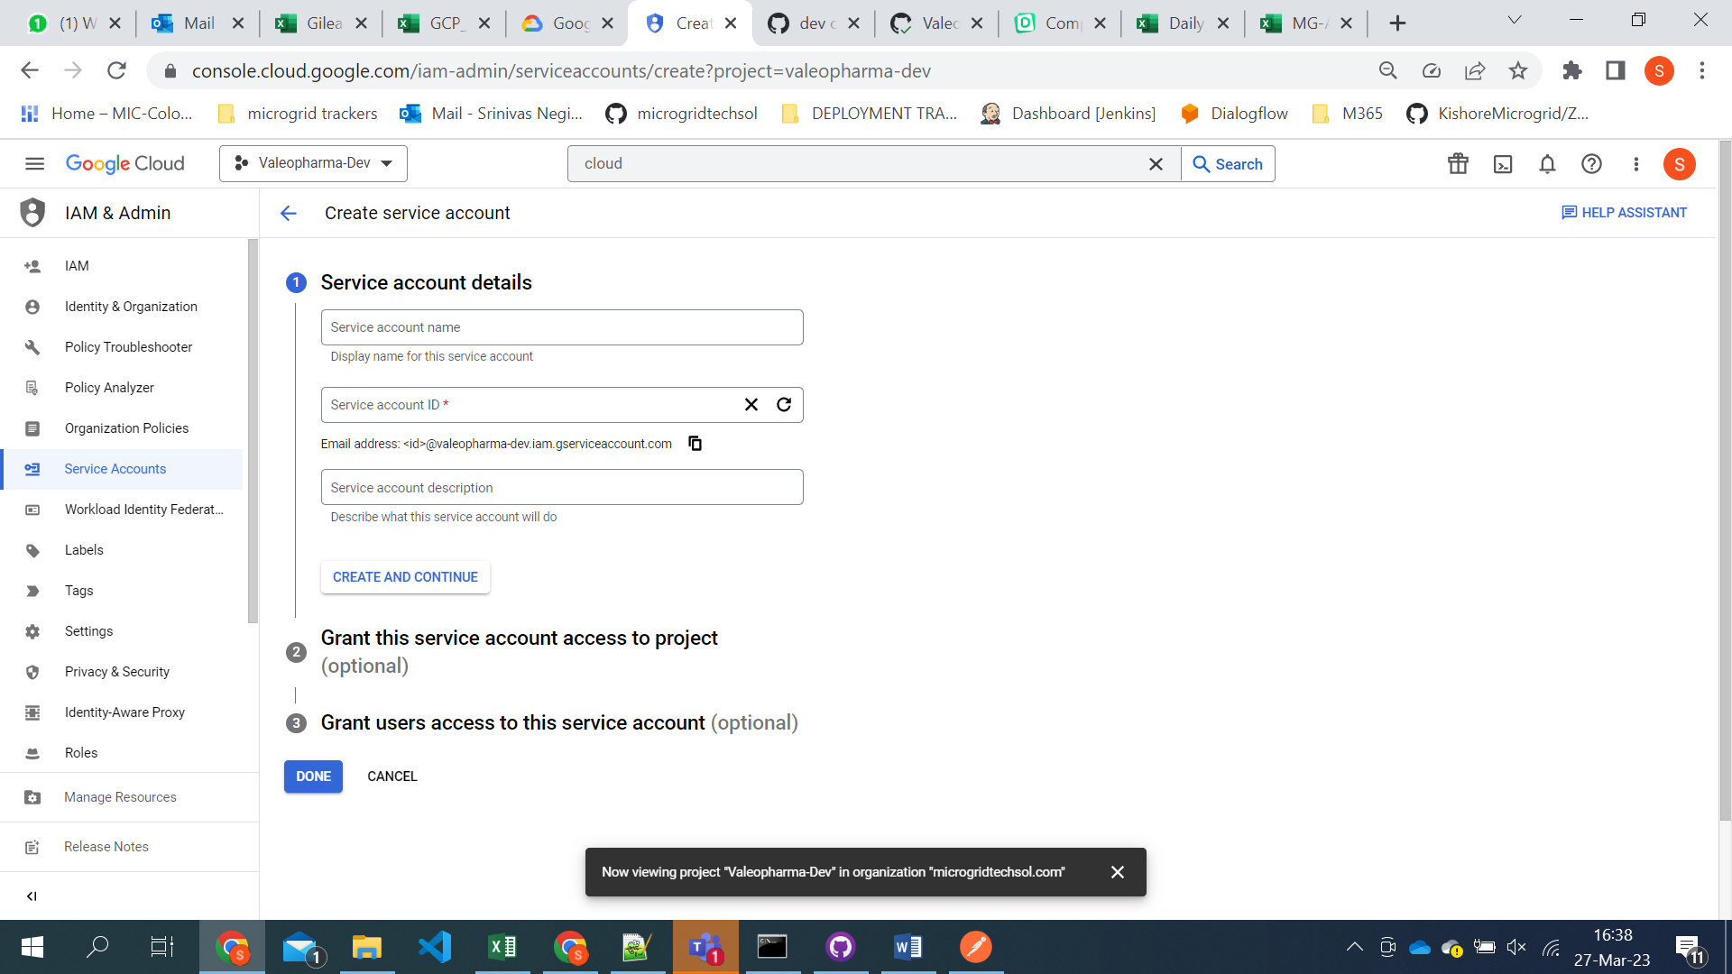

**ADDING CORS POLICY TO THE BUCKET**

1. Open cloud shell and click on open editor

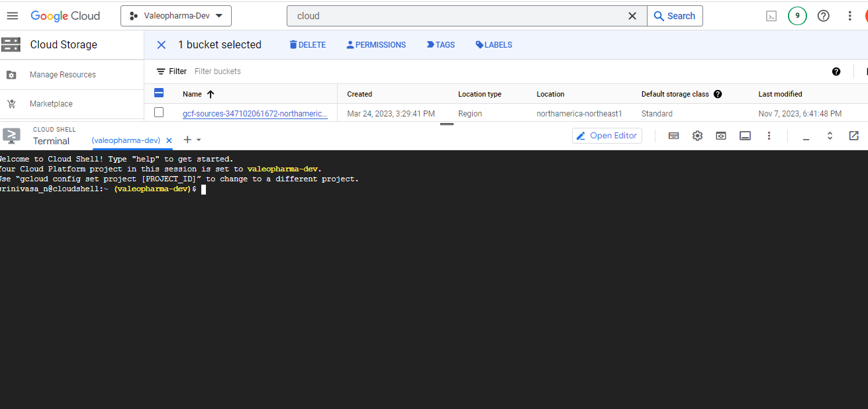

1. Click on create new file and name it cors.json file with below content

[

{

 "origin": ["*"],

 "method": ["GET", "POST"],

 "maxAgeSeconds": 3600

}

]

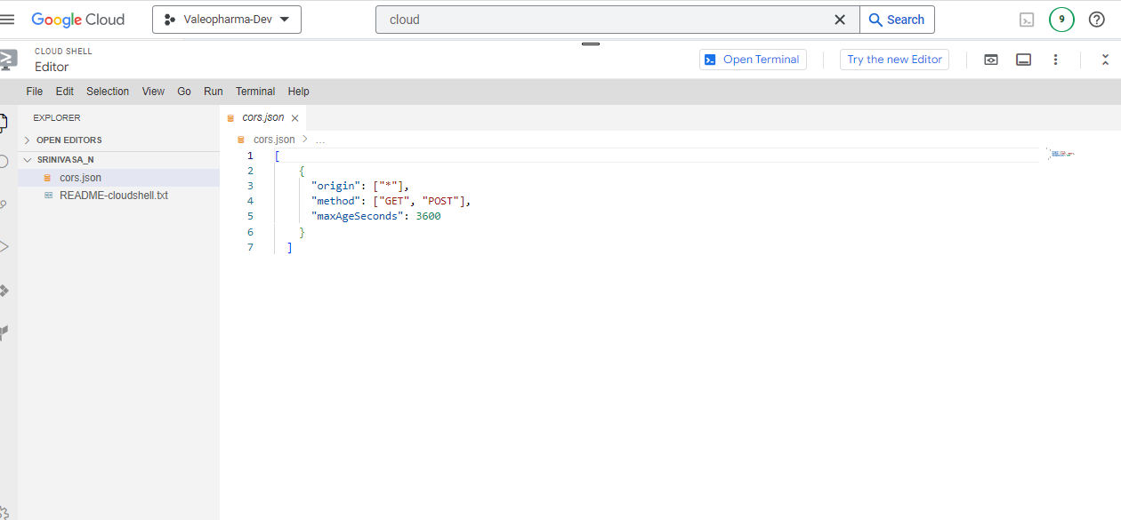save the file and click on open terminal.

1. Execute the below command to set cors policy for the bucket.

**gsutil cors set cors.json [bucket url]**

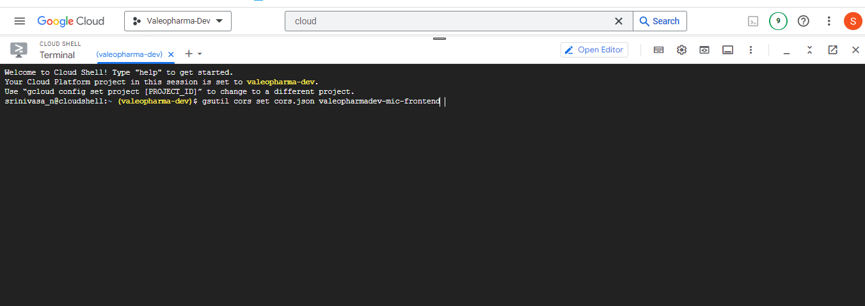

It will set the cors policy for the bucket.